Ethiopia

## GNI per capita and development level

The data set shows the GNI per capita and development level of the country each year.

## # A tibble: 19 x 5  
## country iso3c date GNIperCapita devCategory   
## <chr> <chr> <dbl> <dbl> <chr>   
## 1 Ethiopia ETH 1996 12948. Upper Middle Income  
## 2 Ethiopia ETH 1998 7650. Upper Middle Income  
## 3 Ethiopia ETH 2000 233. Low Income   
## 4 Ethiopia ETH 2002 229. Low Income   
## 5 Ethiopia ETH 2003 263. Low Income   
## 6 Ethiopia ETH 2004 38321. High Income   
## 7 Ethiopia ETH 2005 1504. Lower Middle Income  
## 8 Ethiopia ETH 2006 1711. Lower Middle Income  
## 9 Ethiopia ETH 2007 1874. Lower Middle Income  
## 10 Ethiopia ETH 2008 776. Low Income   
## 11 Ethiopia ETH 2009 1891. Lower Middle Income  
## 12 Ethiopia ETH 2010 340. Low Income   
## 13 Ethiopia ETH 2011 887. Low Income   
## 14 Ethiopia ETH 2012 2158. Lower Middle Income  
## 15 Ethiopia ETH 2013 2215. Lower Middle Income  
## 16 Ethiopia ETH 2014 397. Low Income   
## 17 Ethiopia ETH 2015 1063. Lower Middle Income  
## 18 Ethiopia ETH 2016 378. Low Income   
## 19 Ethiopia ETH 2017 397. Low Income

## GDP growth and economic growth classification

The data set shows the GDP growth and the ecomic growth classification of the country each year.

## # A tibble: 19 x 5  
## country iso3c date GDPannualGrowthRate GDPgrowthCategory4  
## <chr> <chr> <dbl> <dbl> <fct>   
## 1 Ethiopia ETH 1996 12.4 fast growth   
## 2 Ethiopia ETH 1998 -3.46 negative grwoth   
## 3 Ethiopia ETH 2000 6.07 fast growth   
## 4 Ethiopia ETH 2002 1.51 slow growth   
## 5 Ethiopia ETH 2003 -2.16 negative grwoth   
## 6 Ethiopia ETH 2004 13.6 fast growth   
## 7 Ethiopia ETH 2005 11.8 fast growth   
## 8 Ethiopia ETH 2006 10.8 fast growth   
## 9 Ethiopia ETH 2007 11.5 fast growth   
## 10 Ethiopia ETH 2008 10.8 fast growth   
## 11 Ethiopia ETH 2009 8.80 fast growth   
## 12 Ethiopia ETH 2010 12.6 fast growth   
## 13 Ethiopia ETH 2011 11.2 fast growth   
## 14 Ethiopia ETH 2012 8.65 fast growth   
## 15 Ethiopia ETH 2013 10.6 fast growth   
## 16 Ethiopia ETH 2014 10.3 fast growth   
## 17 Ethiopia ETH 2015 10.4 fast growth   
## 18 Ethiopia ETH 2016 9.43 fast growth   
## 19 Ethiopia ETH 2017 9.56 fast growth

## Development trend

The plot shows the development trend of the country.

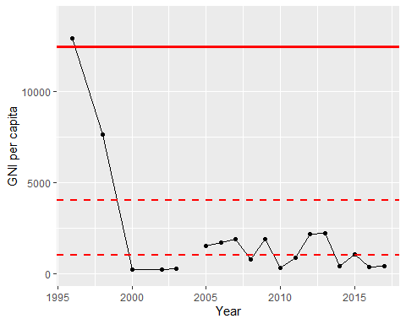

GNI Per Capita Trend